Customer Shopping Behavior Analysis

1. Project Overview
This project focuses on understanding how customers interact with a retail platform by analyzing their purchase behavior across different categories, demographics, and engagement factors.
Instead of just looking at surface-level metrics, the goal was to break down why customers behave the way they do — what drives higher spending, which segments are more valuable, and how factors like discounts, subscriptions, and product categories influence decisions.
To approach this in a structured way, I followed a workflow similar to what is typically used in industry:
- Cleaning and preparing raw data using Python
- Structuring and querying data using SQL
- Building an interactive dashboard in Power BI to communicate insights

Business Problem Statement
A leading retail company wants to better understand its customers’ shopping behavior in order to improve sales, customer satisfaction, and long-term loyalty. The management team has noticed changes in purchasing patterns across demographics, product categories, and sales channels (online vs. offline). They are particularly interested in uncovering which factors, such as discounts, reviews, seasons, or payment preferences, drive consumer decisions and repeat purchases. You are tasked with analyzing the company’s consumer behavior dataset to answer the following overarching business question: “How can the company leverage consumer shopping data to identify trends, improve customer engagement, and optimize marketing and product strategies?”
Deliverables
1. Data Preparation & Modeling (Python): Clean and transform the raw dataset for analysis
2. Data Analysis (SQL): Organize the data into a structured format, simulate business transactions, and run queries to extract insights on customer segments, loyalty, and purchase drivers.
3. Visualization & Insights (Power BI): Build an interactive dashboard that highlights key patterns and trends, enabling stakeholders to make data-driven decisions.
4. Report and Presentation: Write a clear project report summarizing your key findings and business recommendations. Prepare a presentation that visually communicates insights and actionable recommendations to stakeholders.
5. GitHub Repository: Include all Python scripts, SQL queries, and dashboard files in a well- structured repository.

Dataset Summary
The dataset contains around 3900 transaction records capturing different aspects of customer behavior. Each row represents a purchase, along with associated customer and product details.

Key features included:
- Customer attributes like age, gender, and location
- Product-related details such as category and item purchased
- Transaction-level information including purchase amount and discounts
- Behavioral indicators like previous purchases and subscription status
- Customer feedback through review ratings
While exploring the dataset, I noticed that most of the fields were structured well, but there were missing values in the review rating column, which needed to be handled before analysis.
Sample Dataset
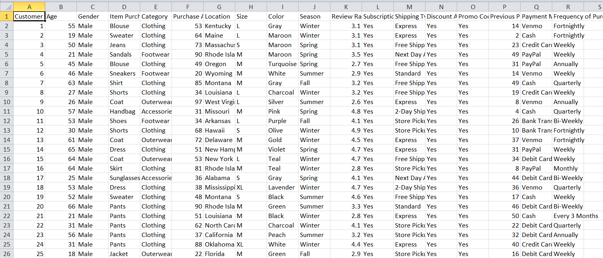

Python Processing

Data Preparation and Processing (Python)
Before jumping into analysis, I focused on making the dataset reliable and easier to work with.
I started by loading the data using pandas and checking its structure using .info() and .describe() to understand data types, ranges, and inconsistencies.
One issue I encountered was missing values in the review rating column. Instead of dropping those rows, I handled them carefully so that I didn’t lose useful data.
To make the analysis more meaningful, I created additional features:
- Converted raw age values into grouped segments like young adult, middle-aged, etc., so comparisons become clearer
- Used previous purchase data to later segment customers into different behavioral groups
I also standardized column names and checked for consistency across categorical variables to avoid issues during SQL querying.

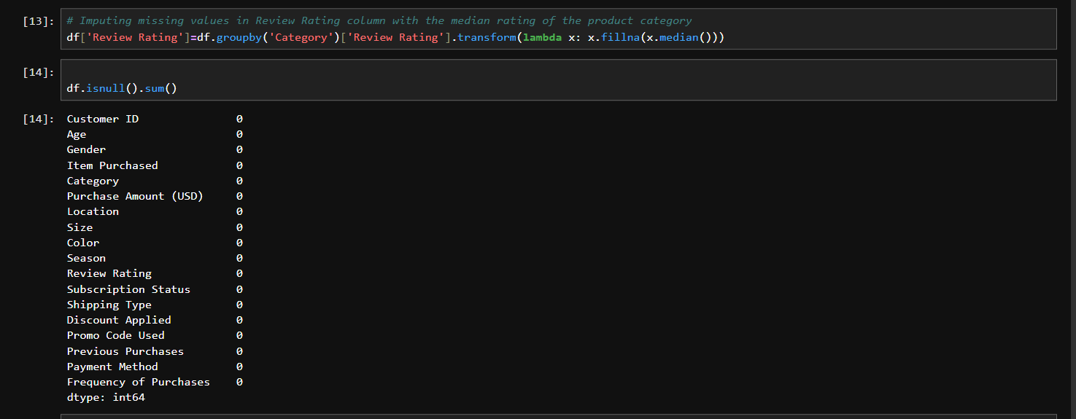
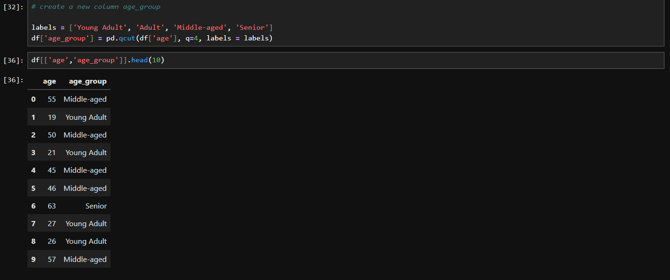
Cleaned Dataset
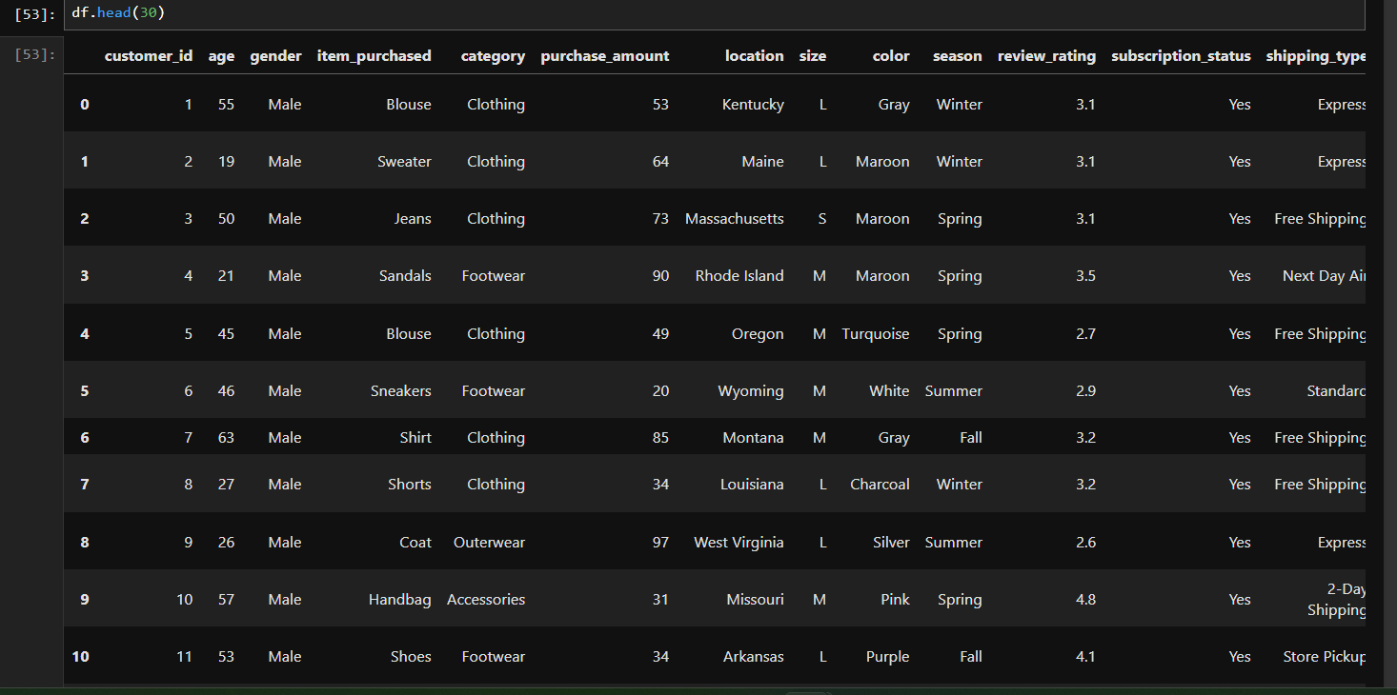

SQL Analysis

Data Analysis using SQL
Once the data was cleaned, I moved it into a structured SQL environment to analyze it from a business perspective.
Instead of random queries, I framed specific business questions and answered them systematically.

Revenue by Gender
I started by comparing how much revenue is generated by male vs female customers. This helps in understanding if one segment contributes more financially.

High-Spending Discount Users
I wanted to check whether discounts are only attracting low-value purchases or if high-value customers are also using them.

Top Rated Products
Customer reviews often reflect satisfaction, so I identified products with the highest average ratings.
I continued the analysis by digging deeper into behavioral and operational patterns.
- Compared average spending between shipping types to see if faster delivery correlates with higher purchase value
- Analyzed subscription vs non-subscription behavior to understand long-term engagement
- Identified products heavily influenced by discounts, which can indicate price sensitivity
- Segmented customers into new, returning, and loyal groups based on their purchase history
- Identified top-performing products within each category
- Checked whether repeat buyers are more likely to subscribe
- Calculated revenue contribution across different age groups
This step helped in moving from raw data to structured insights that can directly support decision-making.
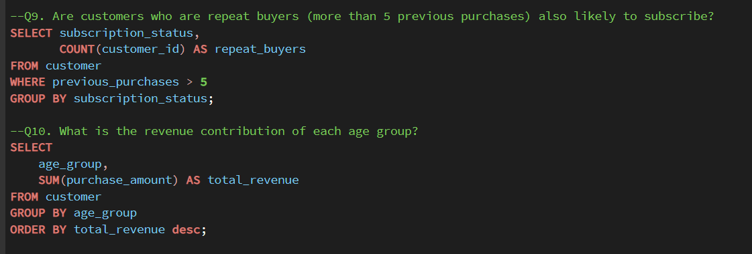
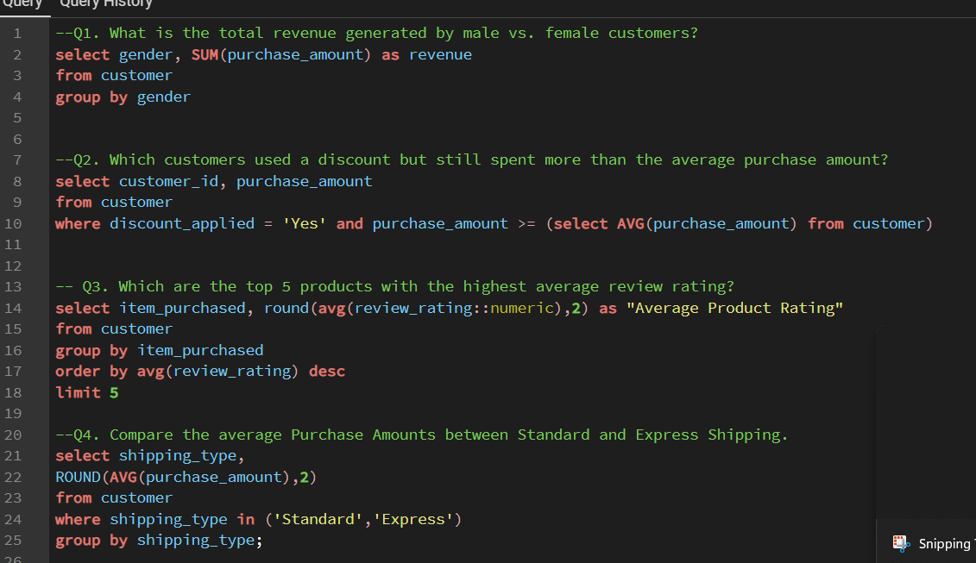
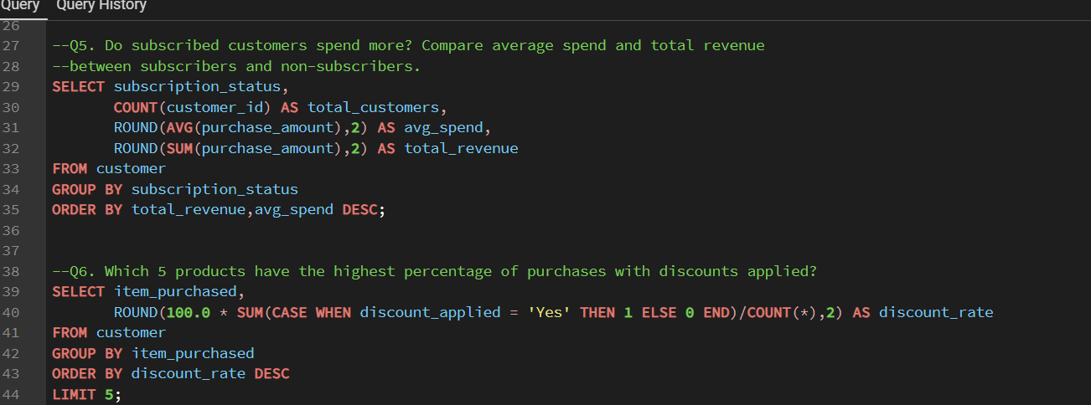
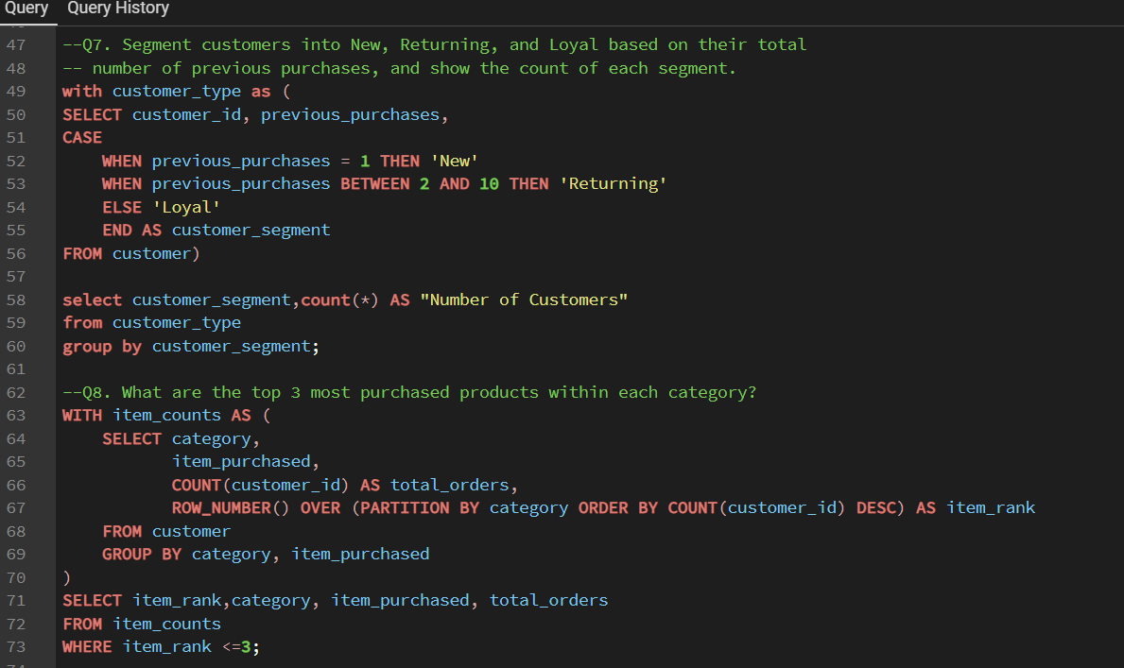

Key Insights
After analyzing the data, a few patterns stood out clearly.
One of the strongest observations was that young adults contribute the highest revenue, which makes them the most valuable customer segment. This suggests that marketing and product strategies should be aligned more closely with this group’s preferences.
Another interesting finding was that non-subscribers generate higher total revenue compared to subscribers. This indicates that the current subscription model may not be delivering enough value to attract or retain high-spending users.
Looking at product performance, the clothing category consistently drives the highest sales, which suggests strong demand and possibly better product-market fit in that segment.
Discount analysis showed that certain products are highly dependent on discounts, which can be a double-edged sword — good for volume, but risky for margins.
Customer segmentation revealed that a large portion of users fall into the loyal category, which is a positive signal for retention, but also an opportunity to further increase lifetime value.

Dashboard

Dashboard Visualization (Power BI)
To bring all these insights together, I built an interactive dashboard in Power BI.
The idea was not just to present numbers, but to make the data easy to explore and interpret.
The dashboard includes:
- KPI cards for quick overview of key metrics
- Category-wise and age-group-wise breakdowns
- Subscription analysis through visual comparisons
- Product-level insights to identify top performers
This allows users to quickly move from high-level metrics to detailed breakdowns without switching tools
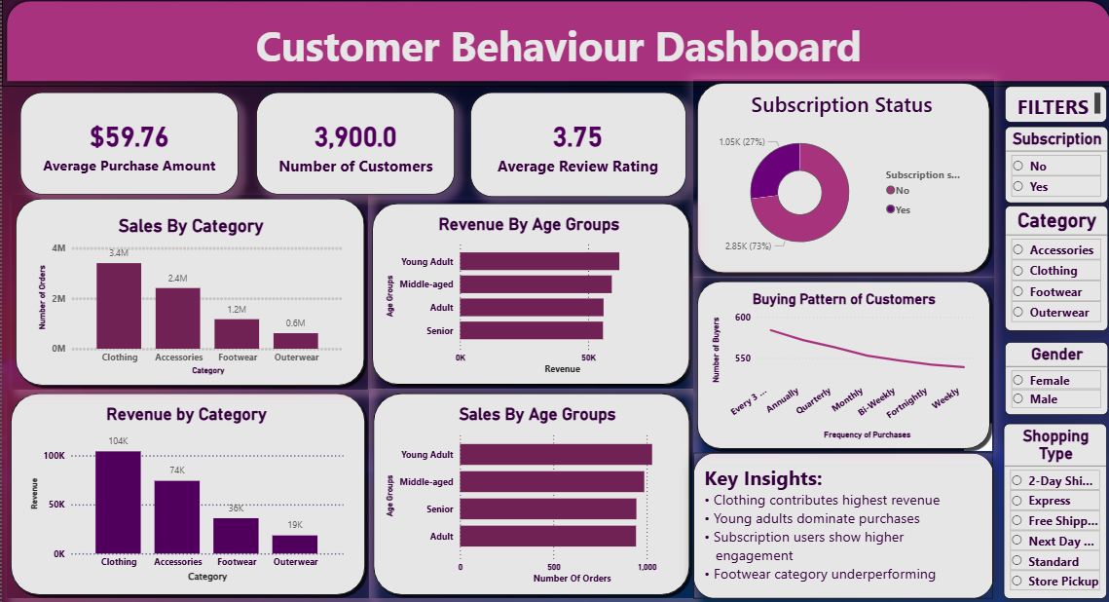

Business Recommendations and Future Scope
Based on the analysis, a few clear actions can be taken.
First, there is a strong case for reworking the subscription model. Since non-subscribers are contributing more revenue, the company needs to rethink what value it is offering through subscriptions. This could include exclusive discounts, faster shipping, or personalized recommendations.
Second, the company should focus more on high-performing segments like young adults. This can be done through targeted campaigns, curated product offerings, or personalized experiences.
Third, while discounts are effective, they should be used more strategically. Instead of applying them broadly, the company can target price-sensitive products and segments, ensuring that margins are not unnecessarily reduced.
From a product perspective, categories like clothing can be further expanded, while underperforming categories may need repositioning or better marketing.
Looking ahead, this analysis can be extended by incorporating time-based data to track trends over months or seasons, which would make the insights even more actionable.
Additionally, integrating customer-level lifetime value and behavioral tracking can help move from descriptive analysis to predictive decision-making.

